**Wipro day – 2**

**Admin Context (Implicit in some cases):**

**Definition:** Although not a distinct context like User or System, many MSI installations that require system-wide changes (like installing a program that runs as a service) might require Admin privileges.

**Access:** These installations require the user to have Admin privileges to run the MSI and perform the necessary system changes.

**Best for:** Installations that modify system files, services, or other resources that require elevated permissions.

**In summary:**

**User Context:**

Limited access to the user's profile.

System Context

: Full system-wide access.

**Admin Context (Implied):** Requires Admin privileges for system-wide changes.

Understanding these contexts is crucial for correctly deploying software using MSI, ensuring the right level of access for the application and its components.

---------------------------------

**Active setup**

It allows users to run specific actions like copying files, updating registry keys, or executing scripts.

-----------------------------------

**1.Leverage Active Setup in MSI Packages:**

**Purpose:** Active Setup allows you to run specific actions (like copying files, updating registry keys, or executing scripts) during the user's logon process.

**How it works:** You can include Active Setup within your MSI package to trigger these actions whenever a user logs in, ensuring user-specific data is available.

**Example:** You can use Active Setup to copy configuration files from a per-machine location into the user's App Data folder during logon.

**2.Create and Assign Logon Scripts:**

**Script Content:** These scripts can be batch files, PowerShell scripts, or even other scripting languages like VBScript.

**Example:** A script might copy user-specific files from a shared network location to the user's profile directory during logon.

**Assignment:** Logon scripts can be assigned to individual user accounts (local or domain) or to groups of users via Group Policy.

**3. Consider Deployment Strategies:**

**Group Policy:** You can deploy logon scripts using Group Policy, assigning them to specific organizational units (OU) or user accounts.

**Software Distribution:** You can use Group Policy Software Distribution to deploy MSI packages, including those that utilize logon scripts or Active Setup.

**Scripting Languages:** Choose a scripting language suitable for your needs. Batch files are simpler, while PowerShell offers more advanced capabilities.

**4. Example Scenario:**

**Copying User Settings Files:**

**Scenario:** An application needs to store user-specific settings files in the user's AppData folder, but these files need to be available immediately upon logon.

**Solution:**

**1. MSI Package:** Include an Active Setup entry that triggers a logon script during user logon.

**2. Logon Script**: Create a script (e.g., a batch file) that copies the application's settings files from a shared network location (e.g., \\server\netlogon\MyApplication) to the user's AppData folder (%AppData%\MyApplication).

**3. Deployment:** Deploy the MSI package and the associated logon script using Group Policy or Software Distribution.

**5.Best practices**

**Error Handling:** Incorporate error handling into your logon scripts to gracefully handle potential issues (e.g., network connectivity problems).

**Security:** Ensure scripts are secure, especially when dealing with sensitive data or file paths. I

**Testing:** Thoroughly test your scripts and deployment process to ensure they work as expected in your environment.

**Documentation:** Document your scripts, deployment procedures, and any related configurations for easy maintenance and troubleshooting.

------------------------------------------

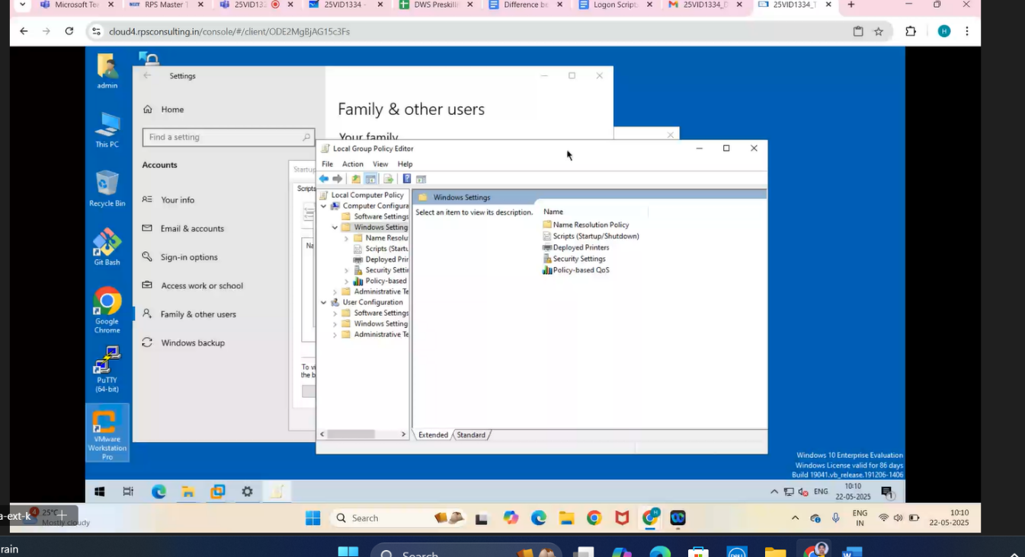

**Local Group Policy (LGP)**

Local Group Policy (LGP) is a feature in Windows that allows you to configure settings for individual computers. It's a more basic version of Group Policy used for standalone or non-domain computers, and can also be applied to domain computers.

------------------------------

**PS means Power Shell.**

------------------------------------